News Release

For Immediate Release: January 2016

Leading St. Louis Builder Stockell Custom Homes Named “Best of Houzz” for Customer Service Excellence, Satisfaction
Stockell Homes Honored Among Millions of Construction Pros on Popular Industry Website

ST. LOUIS, MO — Proven St. Louis builder Stockell Custom Homes & Construction was recently recognized with the “Best of Customer Service” award by Houzz®, a leading platform for home remodeling and design. The Stockell team was selected by the 35 million-plus monthly users of the premier industry site. Stockell Homes has a five-star rating with several customer reviews on building projects with budgets over $100,000.

Each year, the Best of Houzz professionals are distinguished in three categories: design, customer service and photography. As a customer service winner, Stockell Custom Homes ranked high in the quantity and quality of client reviews among other factors.

A “Best of Houzz 2016” badge was added to the company’s profile, as a sign of Stockell’s commitment to service excellence and performance. This badge helps homeowners identify popular and top-rated home professionals in every metro area on Houzz.

“Our team is honored by this award from Houzz,” said Don Stockell, owner of the veteran St. Louis custom home building and remodeling contractor. “Customer service and satisfaction are our highest priorities, so we’re grateful to be recognized in these very areas.”

Positive customer reviews include:
- “Stockell Homes completed a major kitchen remodeling for our home in St. Albans. First class workmanship with excellent subs and suppliers. Stayed on budget and on schedule…This is our second major job with Stockell Homes and they continue to impress us with their work and attention to detail.”
- “We have had a basement finished, bathrooms remodeled, … and a garage addition by Stockell General Contracting. They were very professional, very high quality work, finished before they estimated they would be done and very good at communication. They clean up daily, which doesn't seem important but it really is. I felt Stockell Homes had very fair prices. Don and his team take pride in their work.”

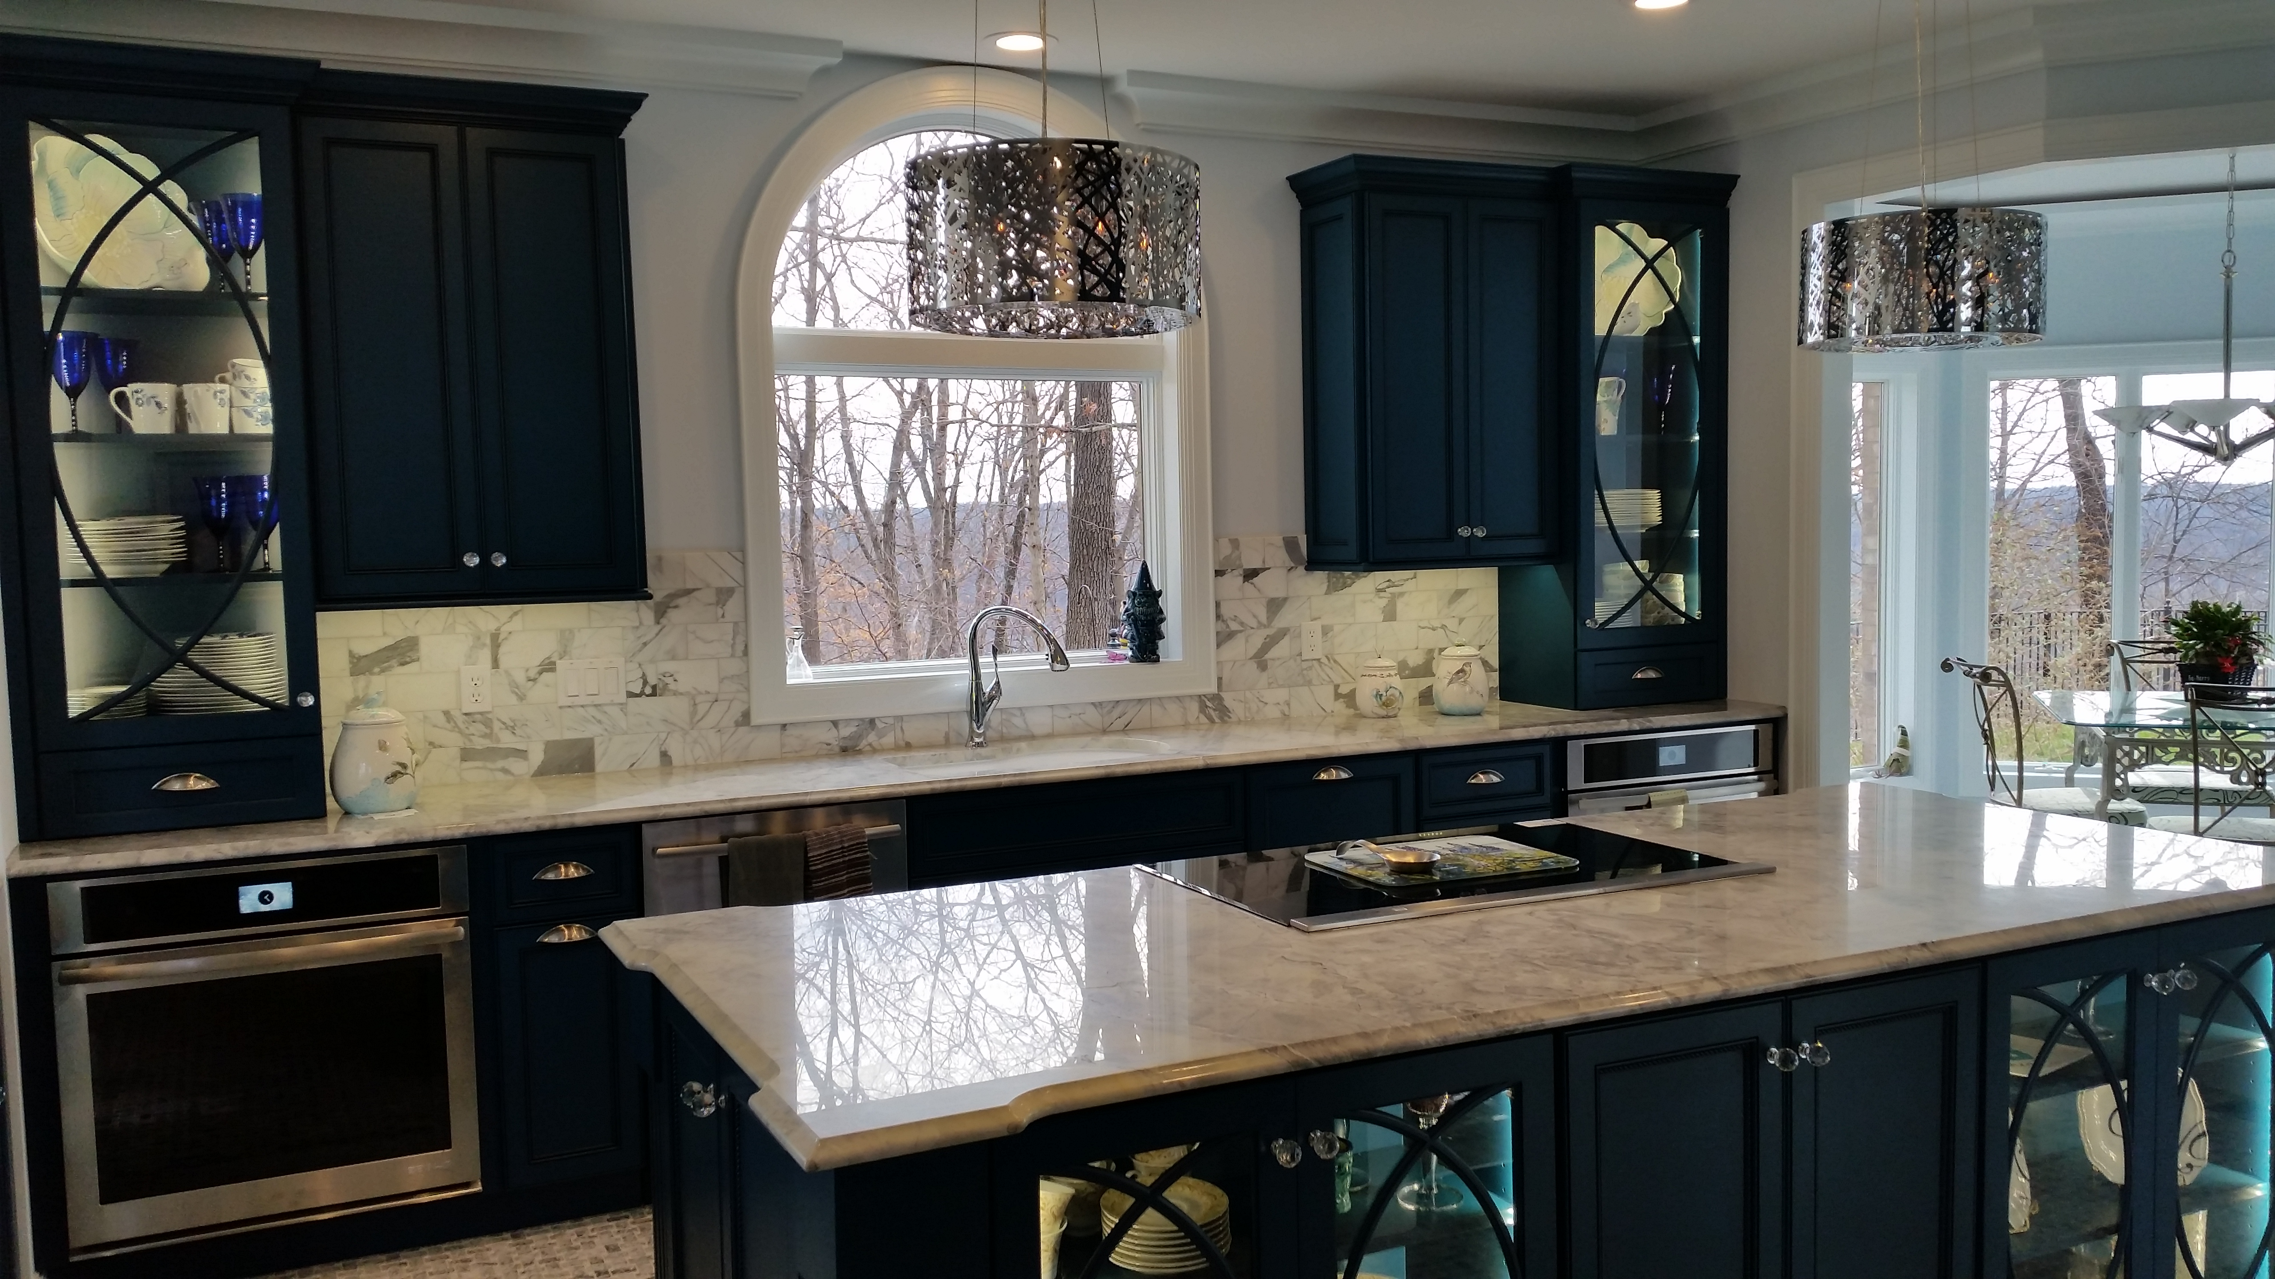

St. Albans, MO kitchen remodel featuring Carrara mosaic tiling, granite countertops,
teal custom cabinetry, elegant hanging lights and recessed lighting

Liza Hausman, vice president of industry marketing for Houzz, said, “Anyone building, remodeling or decorating looks to Houzz for the most talented and service-oriented professionals. We’re so pleased to recognize Stockell Custom Homes & Construction, voted one of our ‘Best of Houzz’ professionals by our enormous community of homeowners and design enthusiasts actively remodeling and decorating their homes.”

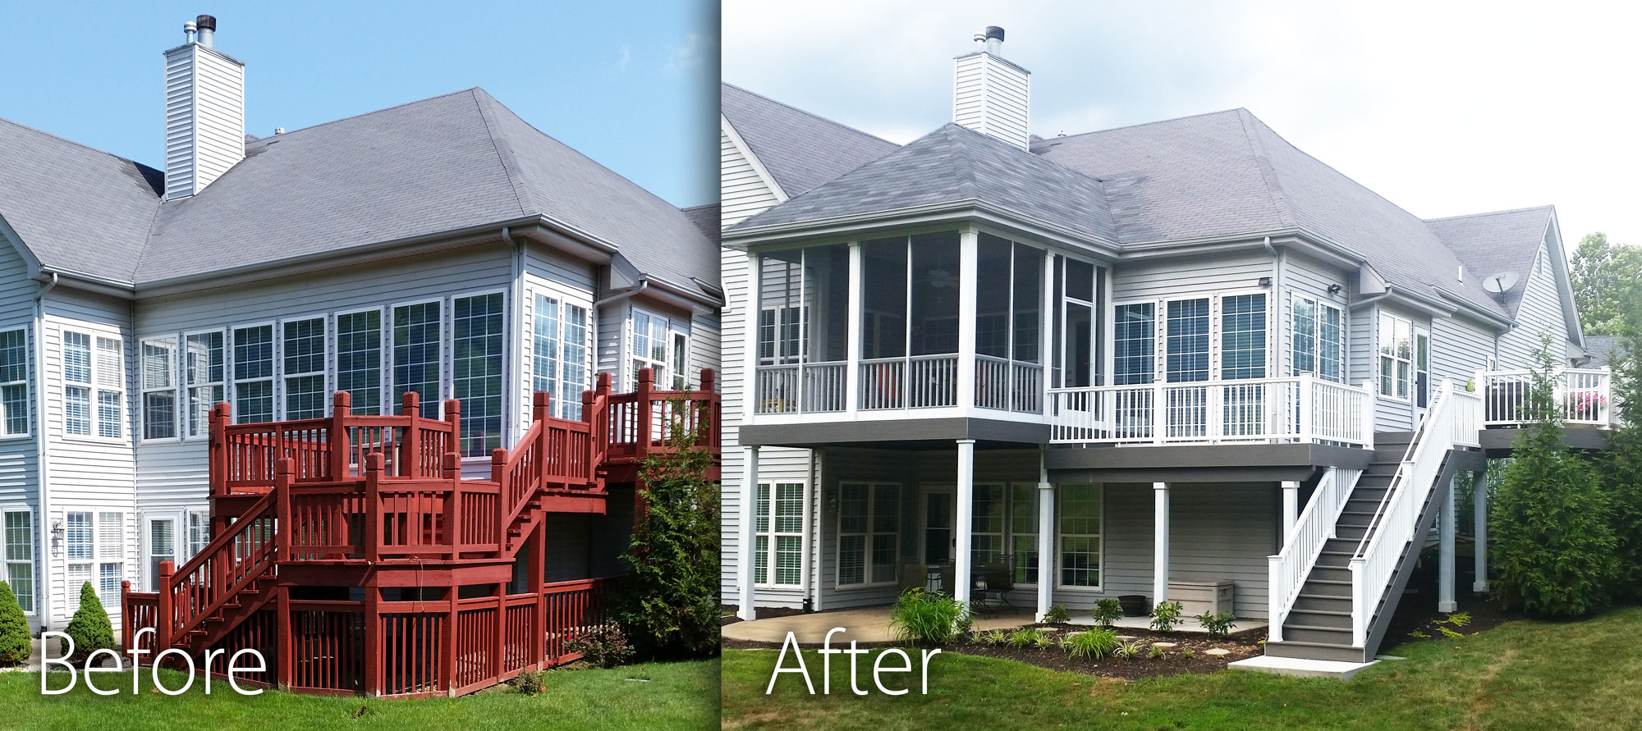

Comprehensive Eureka, MO deck replacement/remodel featuring a streamlined
single-level deck design and matching screened-in porch

- Follow the Stockell team on Houzz.
- Schedule a free custom building or remodeling consultation.
- Read what Stockell’s clients have to say.
- Take a virtual tour of Stockell’s ongoing and completed projects.

About Houzz – www.houzz.com
Houzz is the leading platform for home remodeling and design, connecting millions of homeowners, home design enthusiasts and home improvement professionals throughout the U.S. and internationally. With the largest residential design database in the world (35 million unique monthly users), Houzz
empowers its virtual community with technology to find inspiration get advice, buy products and hire the professionals they need (numbering one million plus) to help turn their ideas into reality. Headquartered in Palo Alto, CA, Houzz also has international offices in London, Berlin, Sydney, Moscow and Tokyo.

About Stockell Homes – www.stockellhomes.com
Since 1986, Stockell Custom Homes & Construction has provided quality construction and remodeling to residential and commercial customers throughout the St. Louis area. The Stockell Team specializes in precision craftsmanship, proactive service, practical green building solutions and on-time, on-budget project delivery.

The company is a National Association of Home Builders member, an Energy Star Partner, and holds an A+ rating with the Better Business Bureau. In addition, leader Don Stockell is a Building Analyst Professional (Building Performance Institute), LEED Accredited Professional and NAHB Certified Green Professional/Approved Verifier.

Connect with Stockell Homes
- Houzz: http://www.houzz.com/pro/stockellhomes/stockell-homes-general-contracting-inc
- Angie’s List: http://www.angieslist.com/companylist/us/mo/wildwood/stockell-general-contracting-inc-and-custom-homes-reviews-6017577.htm
- Facebook: https://www.facebook.com/StockellHomes
- LinkedIn: https://www.linkedin.com/in/donstockell
- Porch: http://porch.com/pros/stockell-custom-homes-2

Press Contacts
- Don Stockell, Stockell Custom Homes and Construction
(636)-938-5333, Email
- Sonia Coleman, Marketing & PR
636-861-7282, Email

