News Release
For Immediate Release: January 2015

Leading St. Louis Remodeler Solves Construction Challenges for Eureka Family
Stockell Homes Details the Two-Story Addition, Lower-Level Refinish in New Case Study
ST. LOUIS, MO. — In its newly published case study, Stockell Custom Homes & Construction details how it solved the functionality, space, comfort and construction challenges faced by a Eureka, Mo. family. The Stockell Team recently completed a comprehensive residential remodeling project on the St. Louis area home, including a seamless two-story addition, screened-in porch and lower-level refinish.

Don and Sherry Beckerle were looking for a more functional living space in multiple areas of their home, including the master bedroom, exercise room, basement and porch areas. But, because of a bad experience with the original contractor, which posed additional issues, they weren’t sure where to turn.

“It was important that we work with a builder we could trust when we decided to expand and remodel,” said Sherry Beckerle. “We chose Don and his team because we heard that Stockell Homes does a great job and is dependable.”

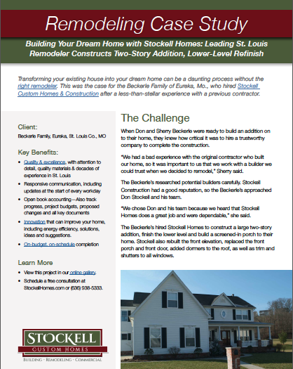

The St. Louis remodeler and custom homebuilder:
- Addressed challenges remaining from the original construction, including redoing the front elevation and replacing the front porch and door.
- Crafted a seamless two-story left addition that expanded the existing laundry, mudroom and master suite and created an exercise space.
- Refinished the lower level, with a custom wet bar, billiards, home theater and salon space.
- Constructed a new screened-in sunroom at the back of the home, and suggested the placement of a hot tub.
- Added trim and shutters to all windows and dormers to the roof.

“We pride ourselves on not only delivering exactly what our clients want, but also doing so on-time and on-budget,” explained Don Stockell, president and owner. “It was a pleasure working with the Beckerles and helping them improve and expand their home. We received a lot of positive feedback from them.”

[MORE]

The Beckerles were very satisfied with the results and the way in which the residential remodel and expansion were carried out. “Stockell Homes did a great job,” said Sherry Beckerle. “It’s evident that Don and his team take pride in their work. We appreciated how approachable they were whenever we had questions or needed anything.”

“It was a drastic difference from our other experience,” she added. “With Don, you get what you’re promised. We’d hire him again in a heartbeat and have already recommended him to other people. Someone with his integrity and work ethic is hard to come by.”

For more information about this project or to set up a free remodeling consultation, call the Stockell Team at 636-938-5333 or fill out the online form.

- Read the full case study: “Building Your Dream Home with Stockell Homes”
- View Stockell’s custom remodeling gallery.
- Remodel or build new utilizing Stockell’s latest green building and energy-efficient technology.

About Stockell Homes
Since 1986, Stockell Custom Homes & Construction (http://www.stockellhomes.com) has provided quality construction and remodeling to residential and commercial customers throughout the St. Louis area. The Stockell Homes Team specializes in precision craftsmanship, proactive service, practical green building solutions and on-time, on-budget project delivery.

The company is a National Association of Home Builders member, an Energy Star Partner, and holds an A+ rating with the Better Business Bureau. In addition, leader Don Stockell is a Building Analyst Professional (Building Performance Institute), LEED Accredited Professional and NAHB Certified Green Professional/Approved Verifier.

Connect with Stockell Homes
- Houzz: http://www.houzz.com/pro/stockellhomes/stockell-homes-general-contracting-inc
- Angie’s List: http://www.angieslist.com/companylist/us/mo/wildwood/stockell-general-contracting-inc-and-custom-homes-reviews-6017577.htm
- Facebook: https://www.facebook.com/StockellHomes
- LinkedIn: https://www.linkedin.com/in/donstockell
- Porch: http://porch.com/pros/stockell-custom-homes-2

Contacts
- Don Stockell, Stockell Custom Homes and General Contracting, Inc.
(636)-938-5333, Email
- Sonia Coleman, Marketing & PR
636-861-7282, Email

